Day 17 - 07th Aug 2026

Task 1:
What is data binding?
Data binding is the process of connecting data (state/variables) with the UI, so that changes in data are reflected in the view and user actions can update the data.
In React, data binding is primarily one-way (unidirectional), meaning data flows from state → UI.

Task 2:
What do you understand by one way data binding and two way data binding?
Types of Data Binding:
- One-way Data Binding: Data flows from component state to UI (React's default).
- Two-way Data Binding: Data flows both ways between UI and data (can be achieved in React using state and event handlers).

Task 3:
When do you use one way data binding and when to use two way data binding?give examples.
One-way data binding is used when data only needs to flow from the state to the UI, making applications easier to manage and debug. React uses one-way data binding by default.
Two-way data binding is used mainly in forms where user input needs to update the state and the updated state should be reflected back in the UI, such as login forms, search bars, and registration forms.

Task 4:
What is the state in react?
State is a built-in React object used to store and manage data that can change over time within a component. When the state changes, React automatically re-renders the component to update the UI.
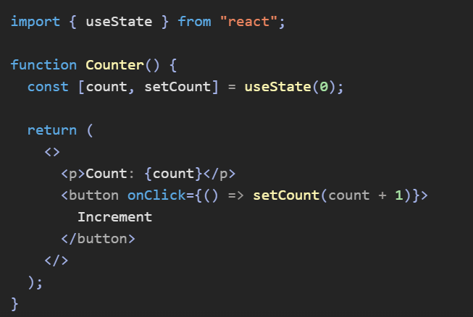

Task 5:
Can you explain SPA?
A Single Page Application (SPA) is a web application that loads a single HTML page once and dynamically updates the content without reloading the entire page when users navigate between different sections.

Task 6:
What is DOM?
DOM (Document Object Model) is a programming interface that represents an HTML document as a tree-like structure of objects (nodes). It allows JavaScript to access and modify the content, structure, and styles of a webpage.

document.querySelector("h1").textContent = "Hello React";

React uses a Virtual DOM, which is a lightweight copy of the real DOM. React first updates the Virtual DOM, compares it with the previous version, and then updates only the changed parts of the real DOM, improving performance.

Task 7:
What is virtual DOM?
Virtual DOM (VDOM) is a lightweight, in-memory copy of the real DOM that React uses to improve performance.
When a component's state or props change:
- React creates a new Virtual DOM.
- Compares it with the previous Virtual DOM (Diffing).
- Identifies only the changed elements.
- Updates those specific parts in the real DOM (Reconciliation).

Real DOM | Virtual DOM
Actual webpage structure | Lightweight copy of the DOM
Slower updates | Faster updates
Re-renders entire affected section | Updates only changed elements
Direct manipulation is expensive | Comparison and selective updates improve performance

Task 8:
What are props in react ? can you explain about prop drilling?
Props (Properties) are used to pass data from a parent component to a child component. Props are read-only, meaning a child component cannot modify them.
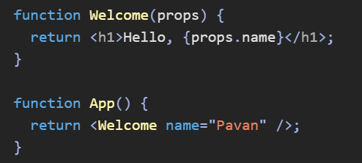
Prop Drilling is the process of passing props through multiple intermediate components just to reach a deeply nested child component.
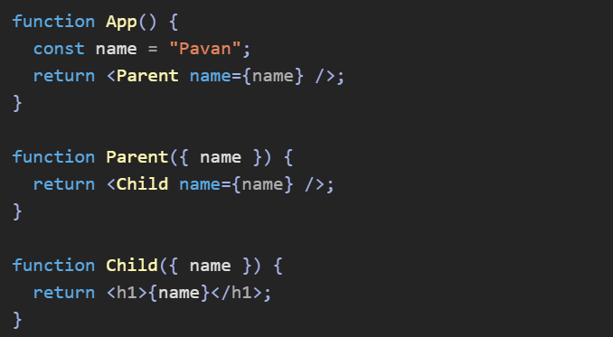

Drilling occurs when props are passed through multiple levels of components to reach a deeply nested component, making the code harder to maintain. React's Context API or state management libraries like Redux can be used to avoid prop drilling

Task 9:
Why do we use react?give importance and describe in detail.
React is a popular JavaScript library used for building fast, interactive, and reusable user interfaces (UIs), especially for Single Page Applications (SPAs).
1. Component-Based Architecture
2. Virtual DOM for Better Performance
3. Reusable Components
4. One-Way Data Flow
5. Easy State Management
6. Strong Community and Ecosystem
7. Cross-Platform Development

Task 10:
What do you understand by component based architecture?
Component-Based Architecture is a design pattern in React where the user interface is divided into small, reusable, and independent components. Each component has its own logic and UI, making applications more maintainable, scalable, reusable, and easier to test.

Task 11:
Explain lifecycle of react component with diagram.. Describe mounting , unmounting etc ..
The React Component Lifecycle refers to the different stages a component goes through from its creation to its removal from the DOM.
There are 3 main phases:
1. Mounting Phase
Mounting is the process of creating and inserting a component into the DOM for the first time.
Constructor() -> Render() -> componentDidMount()

2. Updating Phase
Updating occurs whenever a component's state or props change.
State/Props Change -> Render() -> Component Updated

3. Unmounting Phase
Unmounting is the process of removing a component from the DOM.

Task 12:
What are Hooks in react?why use hooks- importance ? What are different types of hooks?
Hooks are special React functions that allow functional components to use state, lifecycle methods, context, and other React features without using class components. They make code simpler, reusable, and easier to maintain. Common Hooks include useState, useEffect, useContext, useRef, useMemo, useCallback, and useReducer
Built-in Hooks
Provided by React itself:
- useState
- useEffect
- useContext
- useRef
- useMemo
- useCallback
- useReducer
- useLayoutEffect

Task 13:
What is react redux architecture ?explain in detail.
Redux is a state management library used to manage and share application state across multiple React components.
It follows a centralized store architecture, where the entire application's state is stored in a single place called the Store.
Core Components of Redux
1. Store: The Store is the central place where all application state is stored.
2. Action: An Action is a JavaScript object that describes what happened.
3. Reducer: A Reducer is a pure function that receives: current state & action
4. Dispatch: Dispatch sends an action to Redux.

